If you'd like to sign up to donate blood on
Wednesday, Sept. 23, 2020 8:30 - 1:30 pm
at the Clark Building in Hermosa Beach,

Please copy this link into your menu bar to open the form:
https://forms.gle/3sgUPUbKeQdEjBWV8
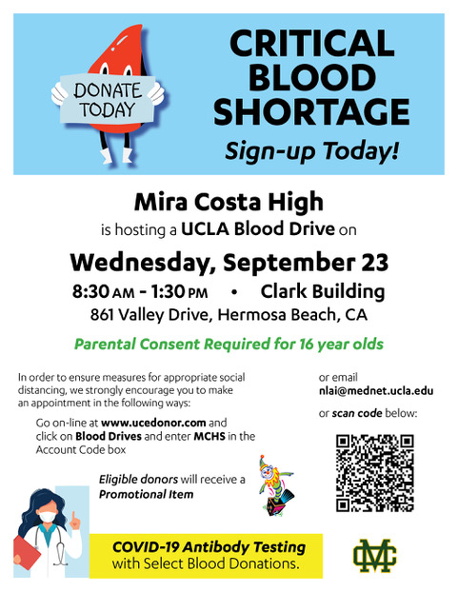
Thanks! -Lisa Claypoole, Director of Student Activities

